Name _______________________________________________________________ Period ___________ Date ___________________________
Cartoon Analysis Worksheet
Step 3: Questions
Level 1
- Identify the cartoon captions and/or the title.

- Locate three words or phrases used by the cartoon to identify objects or people within the cartoon.

- Record any important dates or numbers that appear in the cartoon.
Visuals
Words (not all cartoons include words)
Visuals
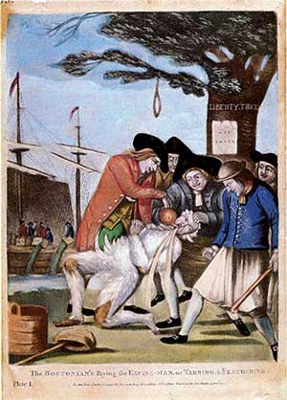
The Bostonians Paying the Excise-Man, 1774

- Describe the action taking place in the cartoon.

- Explain how the words in the cartoon clarify the symbols.

- Explain the message of the cartoon.

- What special interest groups would agree/disagree with the cartoon’s message? Why?

- Which words or phrases in the cartoon appear to be the most significant? Why do you think so?

- List adjectives that describe the emotions portrayed in the cartoon.

- Which of the objects on your list are symbols?

- What do you think each symbol means?

Level 2
Words (not all cartoons include words)
- List the objects or people you see in the cartoon.

Adapted from the National Archives and Records Administration’s Document Analysis Worksheets.

